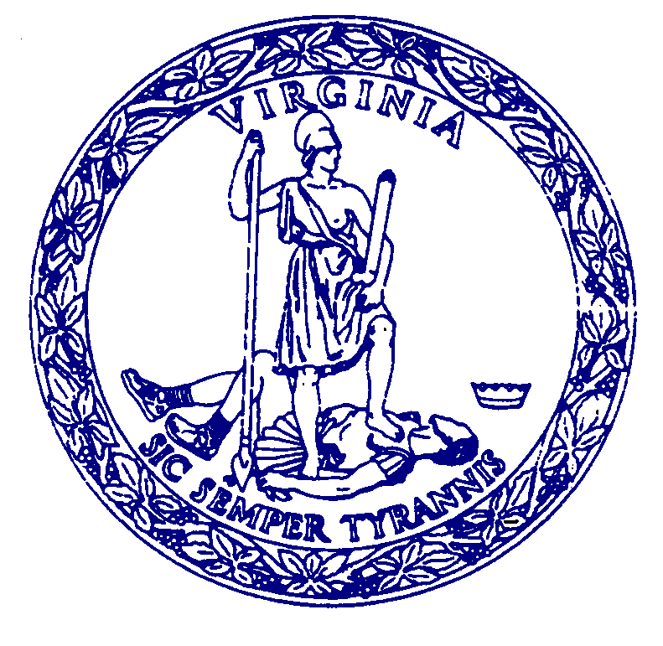**AGENDA**

MEETING

of the

**COMMISSION FOR HISTORICAL STATUES IN THE UNITED STATES CAPITOL**

**1:30 p.m.**

**Wednesday, June 18, 2025**

Virginia Museum of History & Culture

Reynolds Leadership Center – 2nd Floor

428 N. Arthur Ashe Boulevard, Richmond

**Call to Order………………………………………………..……**Senator Louise Lucas, *Chair*

**Roll Call Attendance……………..……………….………………….……**Stephanie Williams

**Approval of Meeting Agenda**

**Approval of February 24, 2024 Meeting Minutes**

**Approval of Virtual Meeting Policy……………………………………...**Stephanie Williams

**Public Comment**…………………………………………………….……..Stephanie Williams

**Presentation of Completed Statue………………….………….…………..…..…**Julie Langan

**Next Steps……………….………………………………………..………………..**.Julie Langan

**Adjourn**